Tech Up social posts (Instagram/FB)

Discover an empowering career as an HVAC tech. The median starting salary is $47,000/year, with the top 10% of techs earning $76,000 and more! [Come to our open house to get started].

Tech Up is what’s up! Being an HVAC technician is a great career that’s open to all education levels. The top 10% of techs earn $76,000 or more. [Come to our open house to learn more.]

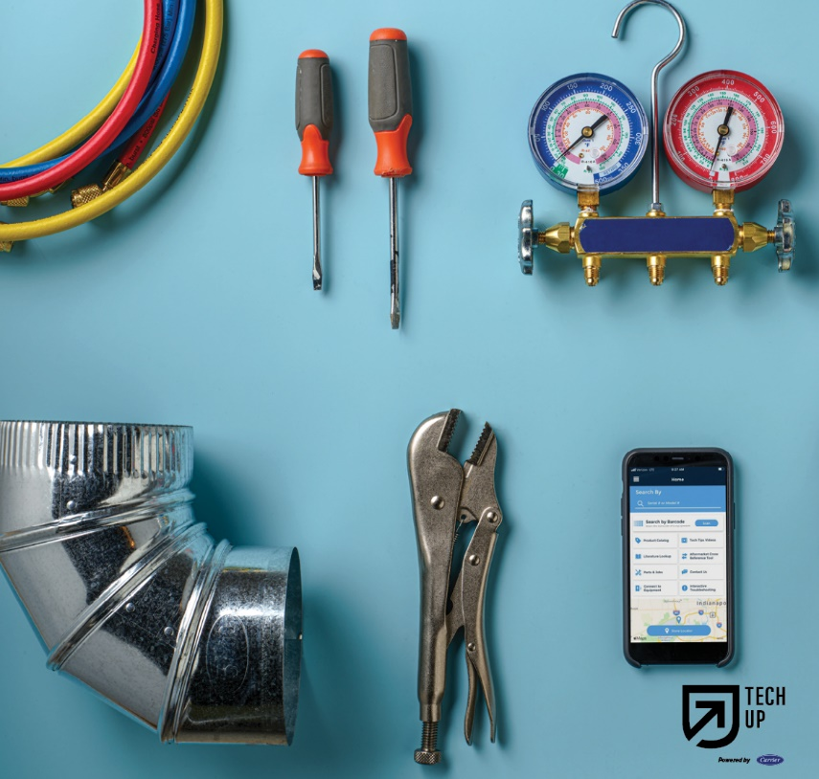https://sp.apps.carrier.com/sites/RCSLegal/Pages/CPM-17-Requests.aspx

[Our HVAC] techs keep homes and buildings comfortable. Join our proud profession and you could earn an average of $47,000 starting out. It’s open to all education levels, [so contact us to get started.]

No two days are the same when you’re an HVAC tech! [Join a fast-paced industry with lots of opportunities to move up and grow your career.] It’s open to all education levels, [so contact us to get started.]

